Mary of Magdala Inclusive Catholic Community
Ash Wednesday Liturgy, March 2, 2022 – 6:30 p.m. CST
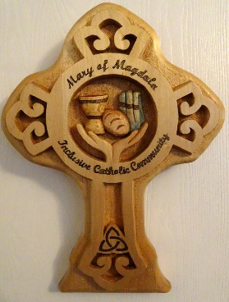
WE GATHER AS COMMUNITY
Greeting
P: Dear Family of Faith, come, be gathered as one in the name of the Holy One: + Source of Being, Eternal Word and Spirit of Wisdom.
All: Amen.
Chime

Acknowledgement of Territory
V1: In the Spirit of Truth and Reconciliation we acknowledge the
Land and the Territory on which we live.
For thousands of years, Indigenous people walked the lands of Turtle Island; relationship with the land is at the centre of their lives and spirituality.
Here in Regina, we are gathered on Treaty 4 territory, traditional lands of the Nêhiyawak (neh HEY o wa), Nahkawé (NUK ah way), Nakota, and homeland of the Métis, Lakota, and Dakota. You may acknowledge the land where you are located.
We acknowledge our responsibilities as settlers and treaty people: that solidarity with our indigenous relatives with whom we share this sacred trust requires active participation in the ongoing struggle for justice, restitution and reconciliation.

Gathering Antiphon
All: Create a pure heart for me, O God; renew a steadfast spirit within me.

Penitential Prayer
P: Dear friends, let us lay aside all our burdens and cares and open ourselves to the Divine presence at the centre of our being, open our ears that we may truly hear God’s voice, and open our hearts to God’s unconditional love.

V2: Disturb us, God,
when we are too well pleased with ourselves,
when our dreams have come true because we have dreamed too little,
when we arrived safely because we sailed too close to the shore.
All: Disturb us, God.

V2: Disturb us, God,
when with the abundance of things we possess
we have lost our thirst for the water of life;
when, having fallen in love with time,
we have ceased to dream of eternity
and in our efforts to build a new earth,
we have allowed our vision of Heaven to dim.
All: Disturb us, God.

V2: Disturb us, God,
to dare more boldly, to venture into wider seas
where storms will show your mastery;
where losing sight of land, we shall find the stars.
All: Disturb us, God.

P: In the name of God who pushed back the horizons of our hopes
and invited the brave to follow.
All: Amen.
(This prayer originally was written by Sir Francis Drake. Bishop Desmond Tutu adapted part of it. It has been further adapted by changing out Lord and male pronouns and to make it a responsive prayer.)

LITURGY OF THE WORD (Comprehensive Catholic Lectionary)

1st Reading: Micah 6:1-8

V3: A Reading from the Prophet Micah

Hear, now, what God says to the prophet:
“Stand up, and plead My case before the mountains.
Let the hills hear your voice.”
The prophet speaks:
"Hear God’s case, you mountains,
and you enduring foundations of the earth.
God has a case against the people.
God will contend with Israel.

God makes complaint against Israel:
“O My people, what have I done to you?
In what have I wearied you? Bring your charges!
I brought you out from the land of Egypt
and freed you from a house of slavery.
And I sent Moses, Aaron, and Miriam to lead you.
Remember now, O My people,
what the ruler Balak of Moab devised,
what Balaam from the clan of Beor answered.
Remember what happened from Shittim to Gilgal,
that you may know My liberating acts," says God.

Israel retorts: “With what shall we come before You,
O God, to show homage in Your Holy Presence?
Shall we enter with burnt offerings, with calves a year old?
Will You, O God, be pleased with thousands of rams,
with ten thousand rivers of oil?
Shall we give our firstborn children for our transgressions,
the fruits of our bodies for the sins of our souls?”

The Prophet responds: “God has told you, O people,
what is good and what is required of you:
to do justice, to love kindness, and to walk humbly with your God.”

The Word of a Prophet.
All: Thanks be to God.

Psalm 78 (excerpts, edited, Merrill)
R: Listen with the ear of your heart and hear the voice of God,
Calling us to respond creatively and share the gifts we have.

Listen well, O peoples of Earth,
to the inner promptings of the Spirit.
For within your heart Love speaks,
not with words of deceit,
but of spiritual truths to guide you upon the paths of peace.
R: Listen with the ear of your heart.

Who will awaken our sleeping minds?
Who will lift up our hearts to the Truth?
Through all generations the rivers have flowed,
but now they are polluted by greed.
Through all the ages Earth has yielded its bountiful harvest;
now valleys, mountains, forests and fields have been misused.
Greed has become the great destroyer of life.
We take without offering back.
We consume Earth’s bounty with abandon.
We leave death, disease, and destruction in our greed wake.
R: Listen with the ear of your heart

We cannot be spared what we have sown.
Generations to come will suffer from our destructive ways.
Their lives will be a mirror to blind and stubborn hearts.
Injustice, will turn back upon hearts oppression and greed of stone.
Children unborn will reap a harvest of lost dreams.
R: Listen with the ear of your heart and hear the voice of God,
Calling us to respond creatively and share the gifts we have.

Even so, the Source of Life remains faithful,
ever ready to lead us out of the wilderness,
to speak to us in the Silence of our Hearts.
When will we live according to Love,
and attune our hearts to the music of the spheres?
Who will rouse us from apathy
and quicken our spirits that we might serve Love?
For, if we turn back to the Beloved,
listening for Love’s voice within our own hearts,
we will live with integrity; we will radiate love.
R: Listen with the ear of your heart and hear the voice of God,
Calling us to respond creatively and share the gifts we have.

The Beloved awaits our response to a new dawn
when peoples of Earth will be united in peace,
where harmony will reign forever in the beauty of diversity,
and all people will know the One Who is Love.
R: Listen with the ear of your heart.
2nd Reading: Romans 7:15-17, 19, 21-22, 24

V4: A Reading from Paul's Letter to the Romans

I don’t understand what I do!
For I do not do what I want. I do what I hate.
If I do what I do not want, I concur that the law is good.
Now it is no longer my better self who does it,
but the immoral inclinations that dwell in me...

For I do not do the good I want,
but I do the evil I do not want...

I discovered the principle that when I want to do right,
evil is at hand. Yet, in my inner self,
I take delight in the law of God!…

Conflicted human that I am!
Who will deliver me from evil?
Who will deliver me from these immoral inclinations?

The Word of the Apostle Paul.
All: Thanks be to God.

Gospel Acclamation
Now I Am Revealing - Richard Bruxvoort Colligan

Now I am revealing new things to you, revealing new things to you,
Now I am revealing new things to you, revealing new things to you,

Things hidden and unknown to you, created just now, this very moment.
Things hidden and unknown to you, created just now, this very moment.(2x)
Abbey of the Arts
Monk in the World: Songs for Contemplative Living
Gospel: Matthew 6:1-6, 16-21

D: A Reading from the Gospel Attributed to Matthew.

Take care not to perform righteous deeds
so that people may see them.
Otherwise, you will have no recompense
from our Loving God.

When you give alms,
do not blow a trumpet before you,
as the hypocrites do in the synagogues and in the streets
to win the praise of others.
Amen, I say to you, they have received their reward.
Instead, when you give alms,
do not let your left hand know what your right is doing,
so that your almsgiving may be secret.
And your Loving God, who sees in secret, will thank you.
“When you pray, do not be like the hypocrites,
who love to stand and pray in the synagogues
and on street corners so that others may see them.
Amen, I say to you, they have received their reward.
Instead, when you pray,
go to your inner room, close the door,
and pray to your Loving God in secret.
And your Loving God, who sees in secret, will thank you.

“When you fast, do not put on a gloomy face
like the hypocrites do. They dishevel themselves,
so that they appear to others to be fasting.
Amen, I say to you, they have received their reward.
When you fast, anoint your head and wash your face,
so that you do not appear to others to be fasting,
except to your Loving God who is hidden.
Your Loving God who sees what is hidden will thank you.

“Do not store up for yourselves treasures on earth,
where moth and decay destroy,
and thieves break in and steal.
Instead, store up treasures in the heavens,
where neither moth nor decay destroy,
nor thieves break in and steal.
For where your treasure is,
there also will your heart be.”

The Gospel of God.
All: Praise to you, Jesus the Christ.

Homily

BLESSING AND DISTRIBUTION OF ASHES

Prayer for the Earth
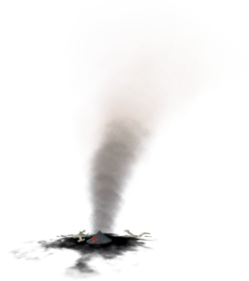
V5: Blessed the earth of which we are made,
The sacred soil of our souls.
Dry and lifeless without water,
Sacred vessel for dew and rain.

Draw near; come close and behold
what shimmers amid the darkness,
endures in hidden places
embers await the breath of life.

Marked as God/de’s own by this earth
Allow the mystery of unnamed possibility
rise from the blazing,
and consume us with its joy.

Break Out Rooms
Share an experience of a dry and weary land. What do you imagine the longing of the earth to be in times of drought? What does is say of your life experience?

Conclude the sharing by going around the circle and blessing one another with the earth you have with you. You may use these or similar words:
With this earth remember that in life and in death, you are God/de’s own.

BLESSING OUR WELLS
P: We turn our attention to the WELL of our prayer center.

Prayer for Water
P: Amidst the dust and ashes we pray:
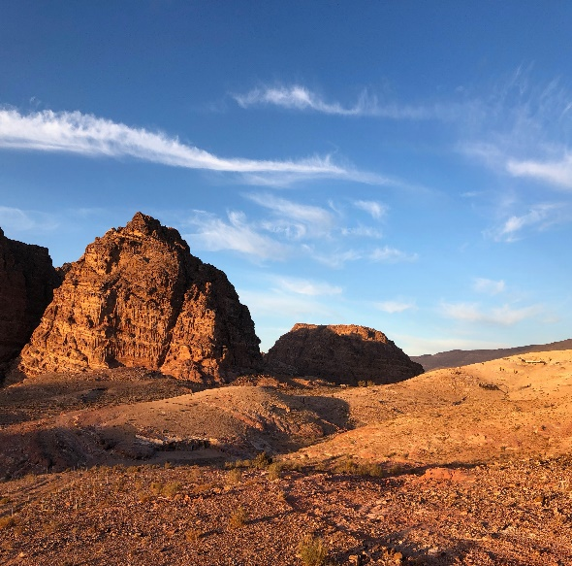
V6: Source of Life,
help us to remember that, for some,
the earth is parched.
We lift to you those for whom clean water
is not a basic right but a luxury,
We cry out, O God/de, against conflict and violence
that leaves crops to wither and
drives families from their homes
to lands where fresh, clean water
is only a dream.

In this season of rebirth,
may we heed your call to hunger
and thirst for righteousness —
and may your justice roll down
as an ever-flowing stream.
All: Amen.

Place the earth you have in the bottom of your container (well) add some water to it; then add the herbs. Place the cutting or seedling next to the well. Each day sing or say The Water Song. Bless yourself with the water asking for wisdom. Tend your cutting or seedling ensuring that it has the water it needs.

Song
The Water Song* Doreen Day
Ne-be Gee Zah- gay- e- goo Water, we love you.
Gee Me-gwetch -wayn ne- me – goo We thank you.
Gee Zah Wayn ne- me- goo We respect you.

PRAYERS OF THE PEOPLE

P: Most Holy One, with humble and contrite hearts we bring our prayers to you knowing that you always hear us and answer us according to your boundless mercy and compassion:

V7: For all believers, that they may be witnesses to their faith and love of you, we pray;
All: Make us faithful witnesses, O God/de.

V7: For all the peoples of the earth who are torn between hope and fear, confidence and anguish, we pray;
All: Make us instruments of justice and peace, O God/de.

V7: For broken families and people in distress from hunger, hatred, or disease, we pray;
All: Make us sympathetic listeners and give us understanding hearts, O God/de.

V7 For all wisdom seekers, that they may find the Divine within themselves, we pray;
All: Make us joyful witnesses of your presence, O God/de.

V7: For each of us here and for all Christian communities gathered for worship, we pray;
All: May we find sustenance for our faith and joyful hope, O God/de.

Prayer of Jesus
P: We pray the prayer Jesus:

V8: Source of all Life, you are within, around and among us.
We celebrate your many names.
Your wisdom come; your will be done, unfolding from the depths within us.
Each day you give us all that we need.
You remind us of our limits and we let go.
You support us in our power, and we act with courage.
For you are the dwelling place within us, the empowerment around us,
and the celebration among us, now and forever.
All: Amen. (Adapted by Miriam Therese Winter)

Closing Prayer:
P: Loving God, we ask you to reveal yourself ever more to us so that in the light of your loving presence, we may see ourselves as we truly are, and learn to accept and love ourselves and others. We pray in all your Holy Names.
All: Amen.

Blessing: (Iona)
P: May the everlasting Holy One shield you wherever you go
And the blessing of God/de be upon you
All: The blessing of the God/de of all life

P: The blessing of Christ be upon you
All: The blessing of the Christ of all love

P: The blessing of the Spirit be upon you
All: The blessing of the Spirit of all grace

D: Let us go into the world rejoicing
It is Christ who goes before us.
All: Thanks be to God, Amen.

You are welcome to stay and visit as you like.
You are invited to give your greetings to all before you leave.

Copyright music used with permission under ONE LICENSE # 738897-A.

* The Water Song
The story of the Nibi (Water) Song told by Beatrice Menase Kwe Jackson, Migizi Clan.

This song was written by Doreen Day at the request of her grandson. She attended a conference about the water in which the internationally known speaker, Dr. Masaru Emoto said, the very least we should do every day, is to speak to the water:
Water, we love you. We thank you. We respect you.

So she did this. Every day on their drive to drop Mashkoonce (Little Elk) to school, they passed a body of water. And every day they said these words to the water as they drove by. They made games by saying it in different voices and then would say it as fast as they could. Then one day Mashkoonce, said, “Nokomis why can’t we say this in our language?” So, Dorene asked her daughter’s language teacher to write it in Ojibwemowin. Dorene had the words taped to the car visor as they learned the words.

One day this grandson Mashkoonce said, “Nokomis why don’t we sing the words, don’t you think the water would like it to be sung?” So she thought about it and came up with the tune. They sang this song to the water every morning on their drive to school.

It is sung like a lullaby and we don’t use shakers or drums.

Doreen and her grandson, Mashkoonce, give permission for everyone to share this song… sing it to the water every day.

Ne-be Gee Zah- gay- e- goo Water, we love you.
Gee Me-gwetch -wayn ne- me – goo We thank you.
Gee Zah Wayn ne- me- goo We respect you.
http://www.motherearthwaterwalk.com/?attachment_id=2244

