Mary of Magdala Inclusive Catholic Community
Regina, SK
31st Sunday in Ordinary Time (All Saints/All Souls)
October 30, 2022 – 10:00 a.m. CST

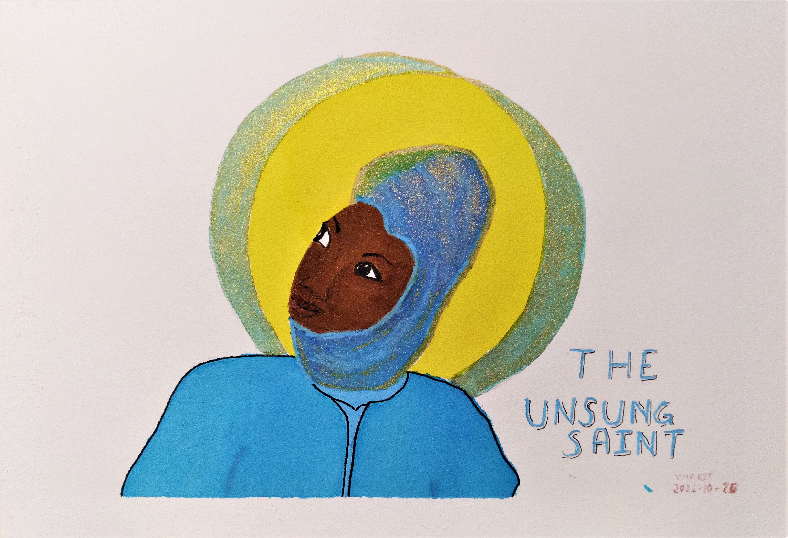
Artist: vikki marie. Used with permission.

WE GATHER AS COMMUNITY

Welcome/Introduction
P: Come dear family of faith. We gather in all the names of the Divine Holy One: Creator, Source of all that is; Jesus, the Christ; and the Sacred Spirit, Holy Wisdom. Amen.

We acknowledge that we are on Treaty 4 territory, traditional lands of the Nêhiyawak (neh HEY o wuk), Nahkawé (NUK ah way), Nakota, and homeland of the Métis, Lakota, and Dakota. We share with them this sacred trust and acknowledge our responsibility to walk together in a good way the path of truth, justice and reconciliation. Chime (3x)

Opening Song
Open My Eyes (Mk 8:22-25)
1. Open my eyes, Lord. Help me to see your face.
Open my eyes, Lord. Help me to see.

2. Open my ears, Lord. Help me to hear your voice.
Open my ears, Lord. Help me to hear.

Bridge: And the first shall be last, and our eyes are opened
and we’ll hear like never before. And we’ll speak in new ways,
and we’ll see God’s face in places we’ve never known.

3. Open my heart, Lord. Help me love like you.
Open my heart, Lord. Help me to love.
©Jesse Manibusan. Published by OCP Publications.

We Remember Our Loved Ones
P: Today we remember those who have gone before us in death and now rest in the Eternal Embrace. Indigenous people believe in their unity with the ancestors, and often call their spirits forth into their gatherings. We call into our midst the presence of all Holy Friends of God and Prophets, their memory and their blessing. Gathered around the Christ Candle, symbol of everlasting light and life, we pray:

Side 1: Spirit of our beloved ancestors,
this day we join in acknowledging the blessedness
of the many who inspired us and shaped our faith.

Side 2: We turn in memory and appreciation
toward those ancestors in our family of origin
who influenced and encouraged us to live as our best selves.

Side 1: We bring to mind others beyond family who enriched our lives
and led us further on our journey of personal transformation.
We honor all those who sacrificed and suffered
in order for peace and justice to be furthered on the planet.

Side 2: We give thanks and rejoice for the countless, unnamed persons
whose lives left a lasting mark of kindness and compassion.

Side 1: May the remembrance of each of these blessed ones
inspire and increase our personal commitment
to leave a trace of goodness wherever we go.

Side 2: When we depart the sphere of life may our inner strength
Have contributed to individual and world peace.
~ Joyce Rupp, Prayer Seeds (adapted)

P: Listen to our prayer, O Loving God/de. As our faith in your Son, raised from the dead, is deepened, may our hope in resurrection for your departed servants also find new strength.
We ask this in the name of the Risen Christ, today and always, now and forever.
All: Amen.

LITURGY OF THE WORD

First Reading: Isaiah 25:6-10a

V: A Reading from the Prophet Isaiah.

On this mountain, the God of All will prepare for You a banquet of rich food, a feast of well-aged wines, fine food filled with marrow, fine wines strained clear. On this mountain, God will lift the veil of those who mourn, the shroud that is cast over all peoples. God will destroy death forever. God will wipe away the tears from every cheek. God will take away all that is shameful from the whole earth. God has spoken. On that day it will be said, “This is our God: this is the One for whom we have waited; this is the One in whom we put our hopes; this is our God who makes us whole. We rejoice! We exult in this unending feast! The hand of God rests on this mountain!”

The Word of the Prophet Isaiah.
Thanks be to God.

Psalm: Wisdom 11:22-12:1
Cantor: Our psalm response is:
I have loved you with an everlasting love, I have called you and you are mine.
I have loved you with an everlasting love, I have called you and you are mine. (Joncas)
All: Repeat

V: Before God, the whole universe is as a grain from a balance, or a drop of morning dew come down upon the earth. Still, You have compassion on all. You can do all things. You forgive, that we may repent. R/

You love all that is. You loathe nothing that You have made. What You hated, you would not have fashioned. How could anything have endured, had You not desired it? How would anything have lasted, had it not been called forth by You? R/

You spare all things, because they are Yours, O God and Lover of life. Your holy breath, Your imperishable spirit, is in all things! R/

Second Reading: Ephesians 4:1-6

V: A Reading from the Letter to the Ephesians.

As a prisoner for Jesus the Christ, I implore you to live a life worthy of the call to which you have been called. Be humble and gentle. Be patient, bearing with one another in love. Be careful to value the unity of the Spirit in the bond of peace. There is one body and one Spirit, just as you were called to one hope, one Christ, one faith, one baptism, one God, Creator of all, who is beyond all and through all and in all.

The Word of a follower of Paul.
Thanks be to God.

Gospel Acclamation:
Alleluia, Alleluia, Alleluia!

Gospel: Luke 18:35-19:10
A Reading from the Gospel attributed to Luke.
Glory to you, O God.

V: As Jesus was approaching Jericho, a blind person was sitting by the road, begging. Hearing a crowd going by, the blind beggar began to inquire what was going on. They said that Jesus of Nazareth was passing by. The one who was blind called out, “Jesus, Heir of David, have mercy on me!”

Those who led the way rebuked and sought to silence the blind person, who then called out all the more, “Heir of David, have mercy on me!” Jesus stopped and commanded that the blind beggar be brought to him. As they were bringing him near, Jesus asked, “What do you want me to do for you?” “Sir,” came the reply, “I want to regain my sight!” Jesus said, “Receive your sight. Your faith has made you well.” Immediately, the one who was blind could see and began following Jesus, glorifying God. When all the people saw it, they gave praise to God.

V: Jesus then entered Jericho and intended to pass through the town. A chief tax collector was there named Zacchaeus. He was rich. Zacchaeus kept trying to see who Jesus was, but on account of the crowd he could not because he was short in stature.

He ran ahead and climbed a sycamore tree to see Jesus who was to pass that way. When Jesus came to the place, he looked up and said, “Zacchaeus! Hurry, come down! I must stay at your house today.” Zacchaeus hurried down and welcomed Jesus joyfully.

All who saw it began to grumble and said, “He has gone to be the guest of a sinner.” Zacchaeus stopped and said to the Teacher, “Look, Rabbi, half of my possessions, I will give to those who are poor. If I have defrauded anyone of anything, I will pay back four times as much.” Then Jesus said to Zacchaeus, “Today liberation has come to this house! Zacchaeus, too, is a child of Sarah and Abraham! For the Chosen One has come to seek out, and gather in, all who are lost.”

The Gospel of God.
Praise to you Jesus the Christ.

Shared Homily

Profession of Faith: Memorial Candles
P: In the Creed we profess our faith in the Communion of Saints, the forgiveness of sin and life everlasting. In this belief we share a solidarity with all people from around the world and across time. Under the outstretched wings of Shechina (the abiding Divine Presence) all are connected in a community of sacred relationships in a circle of grace that encompasses all of creation.
We cherish the memory of our loved ones who have gone before us in life and in death. We hold their presence with us as we say their names: (Say name, why special)

R. Presente! (You are here with us) (light candle)

(Remember names of those entered on the BB Memorial page)
After all are honoured we sing:
I have loved you with an everlasting love, I have loved you and you are mine.
I have loved you with an everlasting love, I have loved you and you are mine. (Joncas)

P: Let us not look for you only in memory,
Where we would grow lonely without you.
You would want us to find you in presence,
Beside us when beauty brightens,
When kindness glows
And music echoes eternal tones…
In every heart that loves you.

May you continue to inspire us:
To enter each day with a generous heart,
To serve the call of courage and love
Until we see your beautiful face again
In that land where there is no more separation,
And where all tears will be wiped from our mind,
[for you have gone no further from us
Than to God/de,
And God/de is ever near.]
John O’Donohue, “On the Death of the Beloved” (adapted)

Prayers Of The People:
P: Guided by our ancestors in faith, let us bring the needs of the world before our God/de.
All: In you tender compassion, you hear our prayer.

V: For a spirit of wisdom for leaders of nations amid the many crisis we face, we pray: R/
For victims of war and all forms of violence, we pray: R/
For Mother Earth and the protection of all life she bears, we pray: R/
For all the unsung saints in our midst as they continue to work for truth and justice to advance your reign of peace, we pray: R/

P: Add your intentions…
Gracious God/de you inspire people across time to live lives of holiness and be your witnesses of justice and mercy. Receive our prayers that we might follow their example and serve you in sincerity and truth. We ask this in the name of Jesus, the Christ. Amen.

EUCHARISTIC PRAYER
(We offer our gifts)
P: Most Holy One, God of Life and Love,
We thank You for creating the universe, and each of us, through Christ the pioneer of our journey, and in the Holy Spirit, the ever-enlivening gift of Divine love.

We offer you these gifts of bread and wine,
fruit of the earth and work of human hands,
May they become for us, and we for the world,
the Body and Blood of Christ Jesus, your son.

All: Bless this bread and bless this wine, / the wheat and the grape,
the farmer and the harvest, / the seed and the sower.

P: God is with us!
All: We are not alone!

P: Let us give thanks to our God of all Creation.
All: We give our thanks and praise.

V: We bless you, God of all Creation,
revealing the creative design of eternal love and goodness
in the expansive diversity of all that you have made.
From the beginning of time, even until now,
you endow our world with grace and beauty.
Even in the midst of the chaos and brokenness of life
you awaken hope and promise for your people
as time and time again you renew your covenant of love with us.
As we gather this holy day, we remember your faithful love
and we join with all creation as we sing:

Holy, Holy:
Holy, Holy, Holy is God/de’s Name.
And Holy, Holy, Holy is God/de’s Name. (Joncas)

V: Creative God/de, source of life and possibility,
gentle touch to the fragile membrane of life;
caring gardener of the wet seed in the dark earth;
Watchful guardian of erupting evolution,
and loving mother to the pain and joy of birth,
we open wide our hearts to receive your silent presence.

(Extend hands over gifts)
P: Spirit of wind and flame hovering over all that is, come upon the gifts we present:
bread from the grain and wine of the grape, the harvest to be won by today’s labours,
all the things which today will increase and all those that will diminish or die,
that they may become for us the nurturing food of this communion table.

V: On the night before he faced his own death, Jesus sat at supper with his companions and friends.
He reminded them of all that he taught them, and to fix that memory clearly with them, he bent down and washed their feet.

P: When he returned to his place at the table, he lifted the bread, spoke the blessing, broke the bread and offered it to them saying:

All: Take and eat it; / this is my body, / my very self being given for you.

P: Then taking the cup of wine, Jesus spoke the blessing and offered it to them saying:

All: Take and drink of it. This is my life-blood, the seal of the new and
everlasting covenant given in love for you and for all,
for reconciliation - that all may be one. Do this in memory of me.

Acclamation: Mass of Louves de Deu, Inca Tradition; words: Sophia 2016
When we eat this life-giving bread; when we share the wine of our lives;
you are here alive in our midst; Holy, Holy, Holy One.

V: Gathered round this table of remembrance, we ask that we, too,
be transformed by the power of your creative Spirit,
so that we share this sacred meal with humility and
serve our brothers and sisters with joy.

V: In union with all your holy ones from ancient days,
we remember our beloved dead,
all those who suffer physical, emotional, mental or spiritual pain,
and all citizens in our world aching for justice and peace.

V: May we spare neither time nor effort to give generously,
to live tenderly, and to act in justice and compassion;
thus helping to build up the Reign of God/de where hatred is diminished,
poverty eradicated, and all people can live in equality, love and peace.

P: We make this prayer to the One who nurtures and sustains,
in the name of Jesus the Risen Christ.
For it is through him, and with him, and in him, in oneness with the Sacred Spirit, that all glory and honour are yours,
Most Holy One, now and forever.

Amen: Mass of Louves de Deu, Inca Tradition; words: Sophia 2016
Bless our God/de forever to reign; Amen, Amen, Amen.

Prayer of Jesus:
P: We pray the prayer Jesus taught his disciples. In Aramaic it begins Abwoon De Bashmaya. (Abwoon same root as Abba – “Energy Force from whom all life comes”)

All: O Birther! Father- Mother of the Cosmos
Focus your light within us - make it useful.
Create your reign of unity now-
through our fiery hearts and willing hands
Help us love beyond our ideals
and sprout acts of compassion for all creatures.
Animate the earth within us: we then
feel the Wisdom underneath supporting all.
Untangle the knots within
so that we can mend our hearts' simple ties to each other.
Don't let surface things delude us,
But free us from what holds us back from our true purpose.
Out of you, the astonishing fire,
Returning light and sound to the cosmos.
May it be so! Translation by Neil Douglas-Klotz

Prayer for Peace:
P: Jesus, you gave us your peace and prayed that all would be one in you.
May our prayers for peace ripple throughout the world.
All: Shalom, Salaam, Shante, Myr, Paz, paix, Peace.
Chime

Invitation to the Table
P: In faithfulness to you, O Christ, we eat this bread and drink this cup.
You reveal yourself to us in the ordinary and unexpected.
As we hold with reverence your sacred memory,
may we come to know who we already are – the Body of Christ.
The gifts of God for the People of God.
All: Thanks be to God/de.

Communion Meditation:
I Am the Bread of Life

- I am the Bread of Life. You who come to Me shall not hunger;
and who believe in Me shall not thirst,
No one can come to Me unless the Father beckons.
Refrain:
And I will raise you up, And I will raise you up,
And I will raise you up, On the last day!
2. The bread that I will give is My flesh for the life of the world,
And if you eat of this Bread, you shall live forever, you shall live forever! R.
3. Unless you eat of the Flesh of the Son of Man and drink of His Blood,
and drink of His Blood, you shall not have life within you. R.
4. I am the Resurrection, I am the Life.
If you believe in me, even though you die, you shall live forever. R.

5. Yes, Lord, I believe that you are the Christ,
The Son of God, who have come into the world. R.
Suzanne Toolan, SM © 1993, GIA Publications, Inc.

Prayer after Communion
P: Gracious and loving God/de, fed by your word and sacrament you transform our lives.
When the fullness of time comes for each of us, may all that is left be love.
Then, with Jesus, this will be our legacy. This is our prayer today and always, now and forever.
All: Amen.

WE GO TO BE WITNESSES
Announcements

Blessing/ Dismissal
(all extend hands in blessing)
P: My dear friends, may we all become unsung saints:
May we walk with faith all the days of our life, confident in your Living Presence. Amen.
May we grow in courage and challenge injustice where’er it prevails. Amen.
May we become bearers of joy, we who are invited to share in the Cosmic Dance. Amen.
and
May the God who dances in creation,
Who embraces us with human love
Who shakes our lives with thunder, +
All: Bless us and drive us out with power.

P: This Eucharist is ended. Let our service begin.
All: Thanks be to God/de!

Copyright music used with permission under ONE LICENSE # 738897-A.
Epitaph ~ Merrit [Mary] Malloy

When I die,
give what is left of me away
to children and old men (and women)
that wait to die.

And if you need to cry,
cry for your brother (or sister)
walking the street beside you.

And when you need me,
put your arms around anyone
and give them
what you need to give me.

I want to leave you something,
something better
than words
or sounds.

Look for me in the people
I've known or loved,
and if you cannot give me away,
at least let me live in your eyes
and not in your mind.

You can love me best
by letting hands touch hands,
(and bodies touch bodies)
and by letting go
of children
that need to be free.

Love doesn't die, people do.
So, when all that's left of me
is love,
Give me away.

